In our previous tutorial, we built a simple button circuit connected to our Pi via the GPIO ports, and programmed a Python script to execute a command when the button was pressed. We then expanded our circuit with an LED. In this tutorial, we’ll be expanding our script to include a timer function to and a trigger function for our LED. As the script will be more complicated, it requires a proper clean-up function, so we’ll code that in too! Please do read the previous two tutorials featured in the MagPi issues 17 and 18 before trying this one!
Adding LED Control Code to our Python Script
Now that our LED expansion circuit is built, we'll add some code into our previous program so we can make the LED flash on and off when the button is pressed. Start by booting your Pi to the Raspian GUI (startx), loading IDLE 3 and opening your file button.py (that we coded in the previous tutorial). Save another copy, rename it to button_led.py and open it.
Since we want the LED to flash on and off, we'll need to add a time module to allow Python to understand the concept of time. We therefore need to import the time module, which adds various time related functionality. Add another line of code beneath line 1:
import time
Next, we need to define GPIO P18 [Pin 12] as an output to power our LED. Add this to our GPIO.setup section (line 4), below the input pin setup line:
GPIO.setup(18, GPIO.OUT)
Once GPIO P18 [Pin 12] has been set to an output we can turn the LED on with the command GPIO.output(18, True). This triggers the pin to high (3.3V) and, because our LED is wired directly to this output pin, it sends a current through the LED, turning it on. The pin can also be triggered low (0V) to turn the LED off, by the command GPIO.output(18, False).
Now, we don’t just want our button to turn on and off, otherwise we would have simply wired it to the button and a power supply. We want it to do something interesting via our Raspberry Pi and Python code, so let’s make it flash by turning it on and off multiple times with a single press of the button!
In order to turn the LED on and off multiple times we are going to use a for loop command. We want the loop to be triggered when the button has been pressed so it needs to be inserted within the if function 'If input_value == False:', that we created in our original program. Add the following below the line 'print(''Who pressed my button!”)' (line 9), making sure the indentation is the same:
for x in range(0, 3):
Any code below this function will be repeated a number a set number of times. Here the loop will run from 0 to 3, therefore running 3 times. Now we'll add some code for the loop so that the LED flashes on and off:
GPIO.output(18, True)
time.sleep(1)
GPIO.output(18,False)
time.sleep(1)
The LED is triggered on with the command GPIO.output(18, True) but since we don't want to immediately turn it back off we have use the command time.sleep(1) from the time module we imported earlier. This means that program waits 1 second before LED is triggered off with the GPIO.output(18,False) command. We use the time command again to wait before the LED is turned back on again.
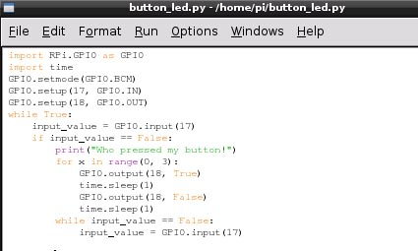
That's our program complete! It should look similar to this in Python:

Save the file and open a new terminal window so we can run the program. Type the following command:
sudo python button_led.py
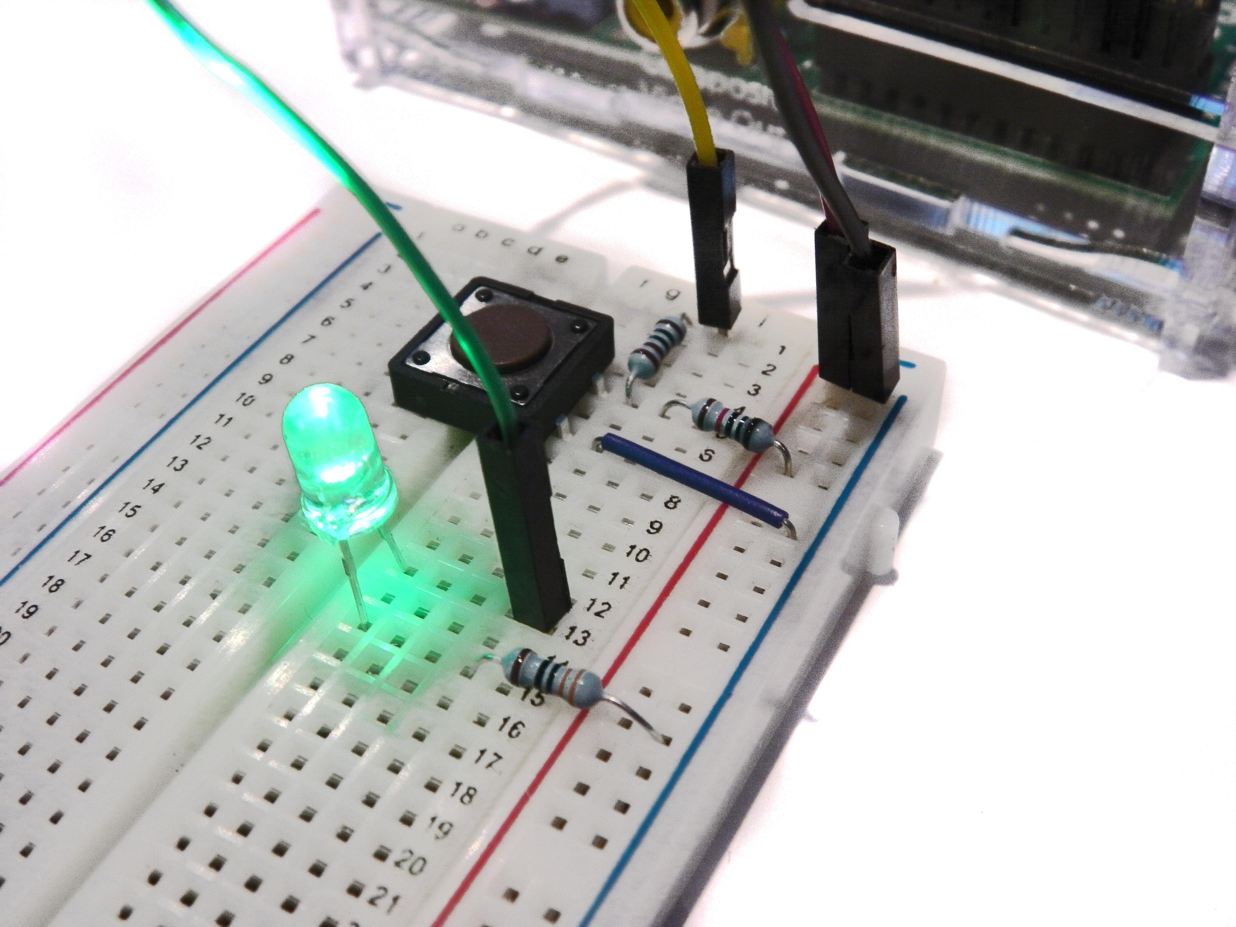
This time when we press the button a message will appear on the screen like before and the LED should also flash on and off 3 times!

To exit the program script, simply hit CTRL+C on the keyboard to terminate.
If it hasn't worked don't worry. Do the same checks we did before. First check the circuit is connected correctly on the breadboard, then that the jumper wires are connected to the correct pins on the GPIO port. Double check the LED is wired the right way round. If it still fails to work, double check each line on the program is correct remembering that Python is case-sensitive and indentation is correct.
If is everything is working fine, next you can start playing around a bit with some of the variables. You can adjust the speed the LED flashes by changing the time the program waits between turning it on and off. If you wanted it flash at 0.1 second intervals change both the time.sleep commands to time.sleep(0.1)
You can also change the number of times the LED flashes by altering the number times our for loop command is repeated. For example if you wanted the LED to flash 30 times, change the command to: for x in range(0, 30).
Have a go playing around with both these variables and see what happens!
Exiting a Program Cleanly
You may notice that when you exit the program and run it again you will see a warning message similar to this:

When a program is terminated (due to an error, a keyboard interrupt (CTRL+C) or simply because it's come to an end) any GPIO ports which were in use will carry on doing what they were doing at the time of termination. Hence, if you try to run the program again, the above warning message will appear when the program tries to 'set' a pin that’s already in use from the previous script. The program will probably run fine but it is good practice to avoid these sorts of messages, especially as your scripts grow larger and more complex!
To help us exit a program cleanly we are going to use the command GPIO.cleanup() which will reset all the GPIO ports to their default values.
For some programs you could simply place the GPIO.cleanup() command at the end of your script, so that when the program ends the GPIO ports are cleaned. However, our program never ends by itself since it constantly loops to check if the button has been pressed. We will therefore use the try: and except commands, so that when our script is terminated by a keyboard interruption, the GPIO ports are cleaned automatically. The following is just an example of how the try: and except command can be used together to exit a program cleanly.
Note. Python will ignore any text placed after hash tags (#) within a script, so it will not affect the code of the program. You may many come across this a lot within Python since it's a good way of annotating your script with notes.
# Place any variable definitions and GPIO set-ups here
try:
# Place your main block of code or loop here
except KeyboardInterrupt:
GPIO.cleanup()
# Program will end and GPIO ports cleaned when you hit CTRL+X
finally:
GPIO.cleanup()

We set up our GPIO pins and import any modules first, and then place the main block of our code within the try: command. This part will run as usual, except when a keyboard interruption occurs (CTRL+C), in which case the GPIO ports are cleaned and the program exits. The command finally: is included so that if our program is terminated by accident if there’s an error (without using our defined keyboard function), the GPIO ports are still be cleaned before exit.
We can add this into our previous program. Open button_led.py in IDLE 3, save another copy of this and rename it button_cleanup.py. Now we can add the above code into our script. It should look like the following in Python:
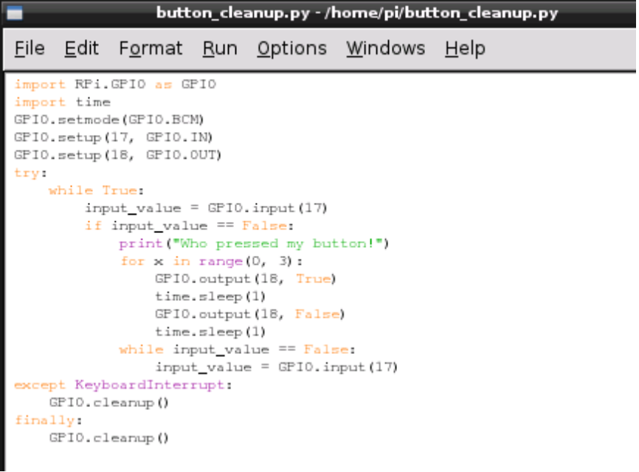
Notice only the loop part of the program is within the try: command. All our imports and GPIO set-ups are left at the top of the script. It’s also important you make sure all your indentations are correct!
Save the file then run the program like before in a terminal window terminal:
sudo python button_cleanup.py
First time you run the file you may see the warning message appear since the GPIO ports haven't been cleaned yet. End the program with a keyboard interruption (CTRL+X). Run the program again and hopefully this time no warning messages will appear!
This extra code may seem like a waste of time because the program still runs fine without it! But when we're programming we always want to try and be in control of everything that's going so it's good practice to add this code so we exit the program cleanly and don't leave any mess behind us!

